HONORS PROGRAM PROJECT PROPOSAL  Type responses in underlined areas.  Attach the completed proposal form to an email message and send to Honors@danville.edu.  The Honors Committee will respond with a request for additional information and/or approval to move forward. | 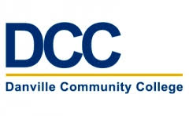

Student Name:

Student Major:

Number of DCC Credit Hours Completed:

DCC Grade Point Average:

Course Prefix and Number for the Proposed Honors Project:

Course Title:

Course Professor / Project Mentor:

Project Description & Purpose:
(Type a thorough description of the who, what, where, why, and when associated with the project; the field will expand.)

Student Signature & Date:

Faculty Mentor Signature* & Date:
*As the project is described, it is my opinion that the time, effort, rigor, and duration of the project will be equivalent to, or exceed, the rigor of a 15- to 20-page research paper accompanied by a 15-minute oral presentation.

NOTE: Attach timeline for project when submitting this form.

